Clairaut’s theorem

Alias

Schwarz’s theorem

Clairaut’s theorem

Young’s theorem

Intro

It says that the symmetric of derivatives for multiple variables is true.

Statement

Given a vector of variables $$vec\left(x\right)$$ = $$\left(x_{1},…,x_{n}\right)$$ and a function $$f:vec\left(x\right)→vec\left(x\right)$$ (i.e. the input is a vector $$vec\left(x\right)$$ type while the ouput is too.)

There is a property, the symmetric of derivatives for multiple variables. More exactly to say, they will return same result if the order of derivatives is changed. That is,

$$\frac{d}{d x_{j}}\left[\frac{d}{d x_{i}}\left[f\left(vec\left(x\right)\right)\right]\right]$$ = $$\frac{d}{d x_{i}}\left[\frac{d}{d x_{j}}\left[f\left(vec\left(x\right)\right)\right]\right]$$

It can be generalized into derivatives many times. That is, for example,

$$\frac{d}{d x_{1}}\left[\frac{d}{d x_{2}}\left[…\frac{d}{d x_{n}}\left[f\left(vec\left(x\right)\right)\right]\right]\right]$$

= $$\frac{d}{d x_{n}}\left[\frac{d}{d x_{n−1}}\left[…\frac{d}{d x_{1}}\left[f\left(vec\left(x\right)\right)\right]\right]\right]$$

Proof of statement

Proof by induction

Suppose:

Suppose $$S\left(n\right)$$ refers the statement is valid and true with given a vector of $$n$$ different variables. Represent with mathematical way, it always holds:

$$S\left(n\right)$$: $$\frac{d}{d x_{1}}\left[\frac{d}{d x_{2}}\left[… \frac{d}{d x_{n}}\left[f\left(vec\left(x\right)\right)\right]\right]\right]$$ = $$\frac{d}{d x_{n}}\left[\frac{d}{d x_{n−1}}\left[… \frac{d}{d x_{1}}\left[f\left(vec\left(x\right)\right)\right]\right]\right]$$

where

$$vec\left(x\right)$$ = $$\left(x_{1},x_{2},..,x_{n}\right)$$

Base step:

For $$n$$ = 1, the following always holds. (It is true and one don’t have to prove it.)

$$S\left(1\right)$$: With given $$vec\left(x\right)$$ = $$\left(x_{1}\right)$$,

$$\frac{d}{d x_{1}}\left[f\left(vec\left(x\right)\right)\right]$$ = $$\frac{d}{d x_{1}}\left[f\left(vec\left(x\right)\right)\right]$$

For $$n$$ = $$2$$,

$$S\left(2\right)$$: With given $$vec\left(x\right)$$ = $$\left(x_{1},x_{2}\right)$$,

$$\frac{d}{d x_{1}}\left[\frac{d}{d x_{2}}\left[f\left(vec\left(x\right)\right)\right]\right]$$ = $$\frac{d}{d x_{2}}\left[\frac{d}{d x_{1}}\left[f\left(vec\left(x\right)\right)\right]\right]$$

To prove it, first use the mean value theorem.

Given a function $$f$$ such that $$f$$ is continuous at $$\left[a,b\right]$$ (of course $$a<b$$) and differentiable at interval $$\left(a,b\right)$$, then there exist $$a<c<b$$ such that

$$f^{′}\left(c\right)$$ = $$\frac{f\left(b\right)−f\left(a\right)}{b−a}$$

Since

$$\inf\left(a<x<b,f^{′}\left(x\right)\right)≤f^{′}\left(c\right)≤\sup\left(a<x<b,f^{′}\left(x\right)\right)$$,

the equality holds.

$$\left|\left|f\left(b\right)−f\left(a\right)\right|\right|≤\left(b−a\right)⋅\sup\left(a<c<b,\left|\left|f^{′}\left(c\right)\right|\right|\right)$$

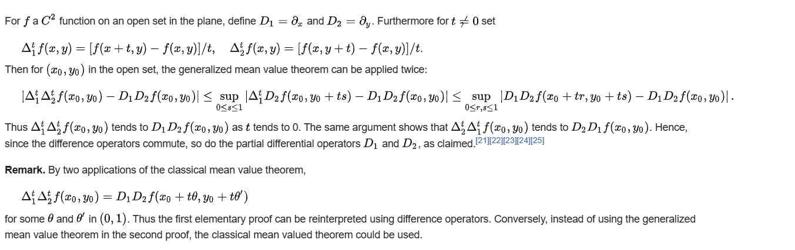

Hence, the proof of base step is completed.

Inductive step:

By inductive hypothesis, $$S\left(k\right)$$ is true

$$S\left(k\right)$$: With given vector $$vec\left(k\right)$$ = $$\left(x_{1},…,x_{k}\right)$$,

$$\frac{d}{d x_{1}}\left[\frac{d}{d x_{2}}\left[… \frac{d}{d x_{k}}\left[f\left(vec\left(x\right)\right)\right]\right]\right]$$ = $$\frac{d}{d x_{k}}\left[\frac{d}{d x_{k−1}}\left[… \frac{d}{d x_{1}}\left[f\left(vec\left(x\right)\right)\right]\right]\right]$$

One has to prove for $$S\left(k+1\right)$$ is also true.

$$S\left(k+1\right)$$: With given vector $$vec\left(x\right)$$ = $$\left(x_{1},…,x_{k+1}\right)$$

$$\frac{d}{d x_{k+1}}\left[\frac{d}{d x_{k}}\left[… \frac{d}{d x_{1}}\left[f\left(vec\left(x\right)\right)\right]\right]\right]$$

= $$\frac{d}{d x_{1}}\left[\frac{d}{d x_{2}}\left[… \frac{d}{d x_{k+1}}\left[f\left(vec\left(x\right)\right)\right]\right]\right]$$

$$\frac{d}{d x_{k+1}}\left[\frac{d}{d x_{k}}\left[… \frac{d}{d x_{1}}\left[f\left(vec\left(x\right)\right)\right]\right]\right]$$

= $$\frac{d}{d x_{k+1}}\left[\frac{d}{d x_{1}}\left[… \frac{d}{d x_{k}}\left[f\left(vec\left(x\right)\right)\right]\right]\right]$$

(by inductive hypothesis)

= $$\frac{d}{d x_{1}}\left[… \frac{d}{d x_{k}}\left[\frac{d}{d x_{k+1}}f\left(vec\left(x\right)\right)\right]\right]$$

(by base step)

which completes the proof.

Method 2:

By iterated integrals.

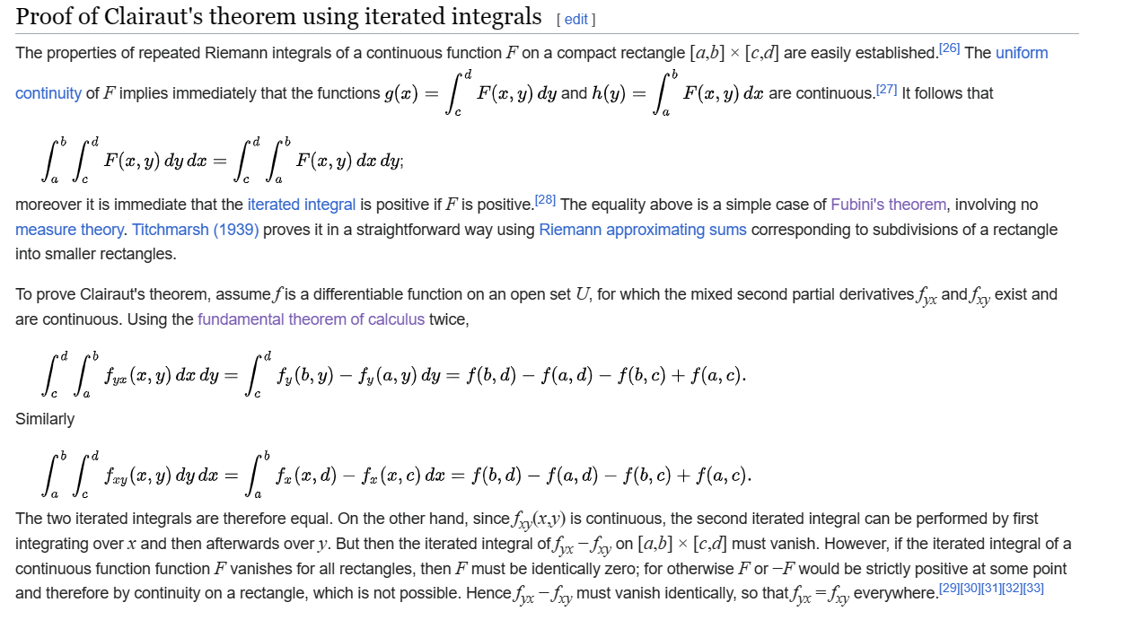

Ref

For a shorter but less detailed about proof of Clairaut’s theorem, see

[Symmetry of second derivatives - Wikipedia](https://en.wikipedia.org/wiki/Symmetry_of_second_derivatives#Schwarz's_theorem)

For a more detailed but longer proof of it, see

[Wayback Machine (archive.org)](https://web.archive.org/web/20060518134739/http://are.berkeley.edu/courses/ARE210/fall2005/lecture_notes/Young%27s-Theorem.pdf)